Data Management Plan Report

TA23 (TEAM Disaster)

Yuchen Luo

Feigang Wang

Hang Cui

Zhengye Chen

Contents

**Introduction** 3

**Open data** 3

**Iteration 01** 4

**Data processing** 4

**Data storage** 6

**Reference** 7

# **Introduction**

The aim for this report is to document the open data we are using, and how they are wrangled, cleansed, transposed, stored and archived.

# **Open data**

|  |  |  |  |  |  |  |
| --- | --- | --- | --- | --- | --- | --- |
| **Names** | **Physical access** | **Frequency of ITERATION System updates** | **Frequency of source updates** | **Granularity** | **Link Address** | **Copyright** |
| AUSTRALIA WILDFIRE 2020 / INVESTIGATION FOR TURKEY | CSV | Every 2 week | Never | Lat & lon,  Day & night & frp | https://www.kaggle.com/code/brsdincer/australia-wildfire-2020-investigation-for-turkey/data | <https://www.kaggle.com/general/116302> |
| Tropical cyclone databases | CSV | Every 2 week | daily | Lat & lon,  Type, | http://www.bom.gov.au/cyclone/tropical-cyclone-knowledge-centre/databases/ | A Creative Commons (CC) Attribution 3.0 licence. |

# **Iteration 01**

## **Data processing**

Using R to combine all 4 dataset, and select the columns we want.

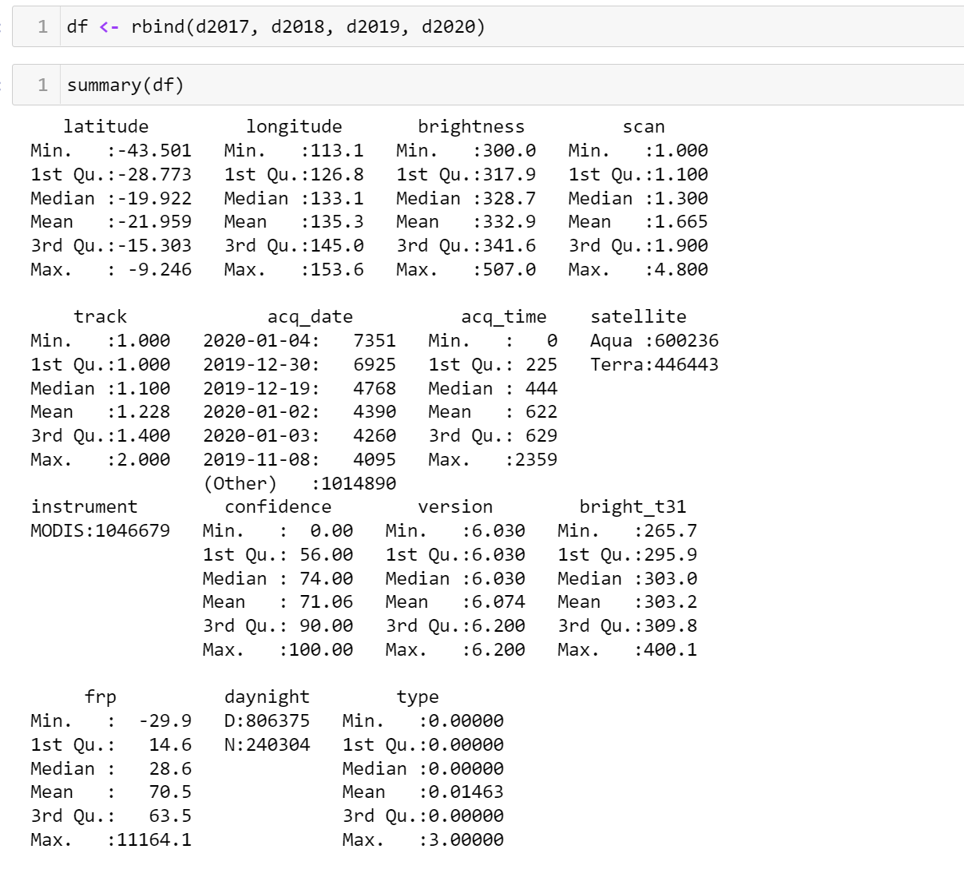

Like picture showing above, the only columns we are using is:

* “latitude” + “longitude”: indicates location for every bushfire from 2017-2020;
* “acq_data”: indicates time when satellite capture the picture of the fire;
* “frp”: fire radiative power, indicates the power of bushfires;
* “daynight”: indicates whether “day time” or “night time” capture the fire.

Therefore, drop the irrelevant columns of the dataset:

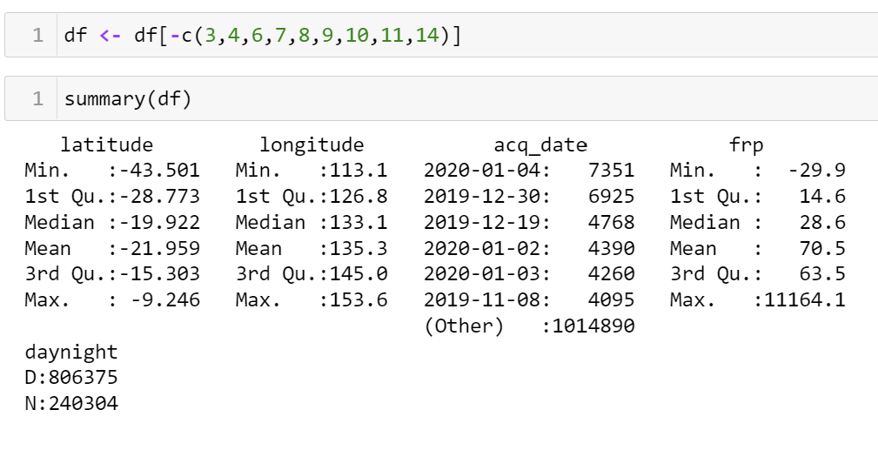

Next, separate “acq_data” into three columns “Year”, “Month” and “Day” to make the filter function more easily operate:

Finally, according to Ichoku et.al (2008), there are five categories for determining the fire level according to frp, category 1 (< 100 MW), category 2 (100 to 500 MW), category 3 (500 to 1000 MW), category 4 (1000 to 1500 MW), and category 5 (> 1500 MW). Because from category 3, the situation can be considered pretty serious, so we only select locations where “frp” > 500.

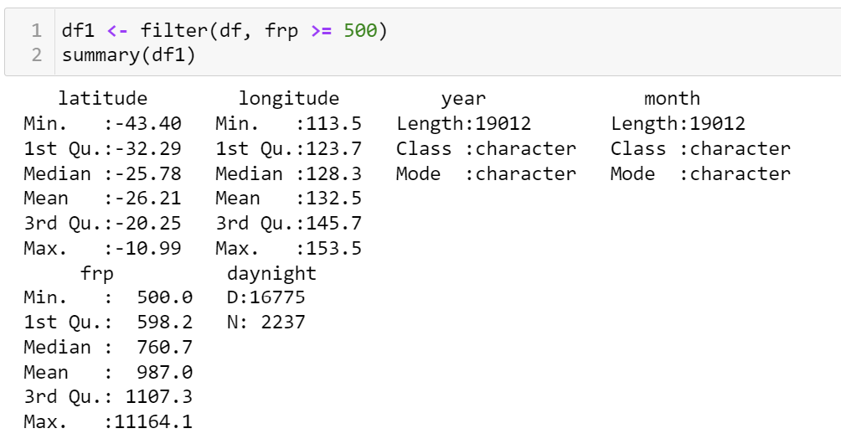

Finally, we write the processed data into a new file.

## **Data storage**

All the processed data are uploaded into “Data Governance” folder, and the processing code are stored, in case the lost of the data.

# **Reference**

* Ichoku, C, Giglio, L, Wooster, M, Remer, L. 2008. Global characterization of biomass-burning patterns using satellite measurements of fire radiative energy. Remote Sensing of Environment. Volume 112, Issue 6, 16 June 2008, Pages 2950-2962. <https://www.sciencedirect.com/science/article/pii/S003442570800062X>